**DAILY ONLINE ACTIVITIES SUMMARY**

|  |  |  |  |  |  |  |  |  |
| --- | --- | --- | --- | --- | --- | --- | --- | --- |
| **Date:** | 24-06-2020 | | | | | **Name:** | Anvitha H M | |
| **Sem & Sec** | 4th ‘A’ | | | | | **USN:** | 4AL18CS010 | |
| **Online Test Summary** | | | | | | | | |
| **Subject** | | N/A | | | | | | |
| **Max. Marks** | | 30 | | **Score** | | | - | |
| **Certification Course Summary** | | | | | | | | |
| **Course** | Data visualization using Tableau. | | | | | | | |
| **Certificate Provider** | | | Great learning academy | | **Duration** | | | 13 hours |
| **Coding Challenges** | | | | | | | | |
| **Problem Statement:** Java program to find occurrence of word. | | | | | | | | |
| **Status:** Executed | | | | | | | | |
| **Uploaded the report in Github** | | | | | YES | | | |
| **If yes Repository name** | | | | | <https://github.com/alvas-education-foundation/Anvitha-H-M> | | | |
| **Uploaded the report in slack** | | | | | Yes | | | |

**Online test:**

N/A

**Certification course:**

Data visualization using Tableau.

The course includes detailed explanation on introduction to dashboard, special types of charts, funnel and control charts.

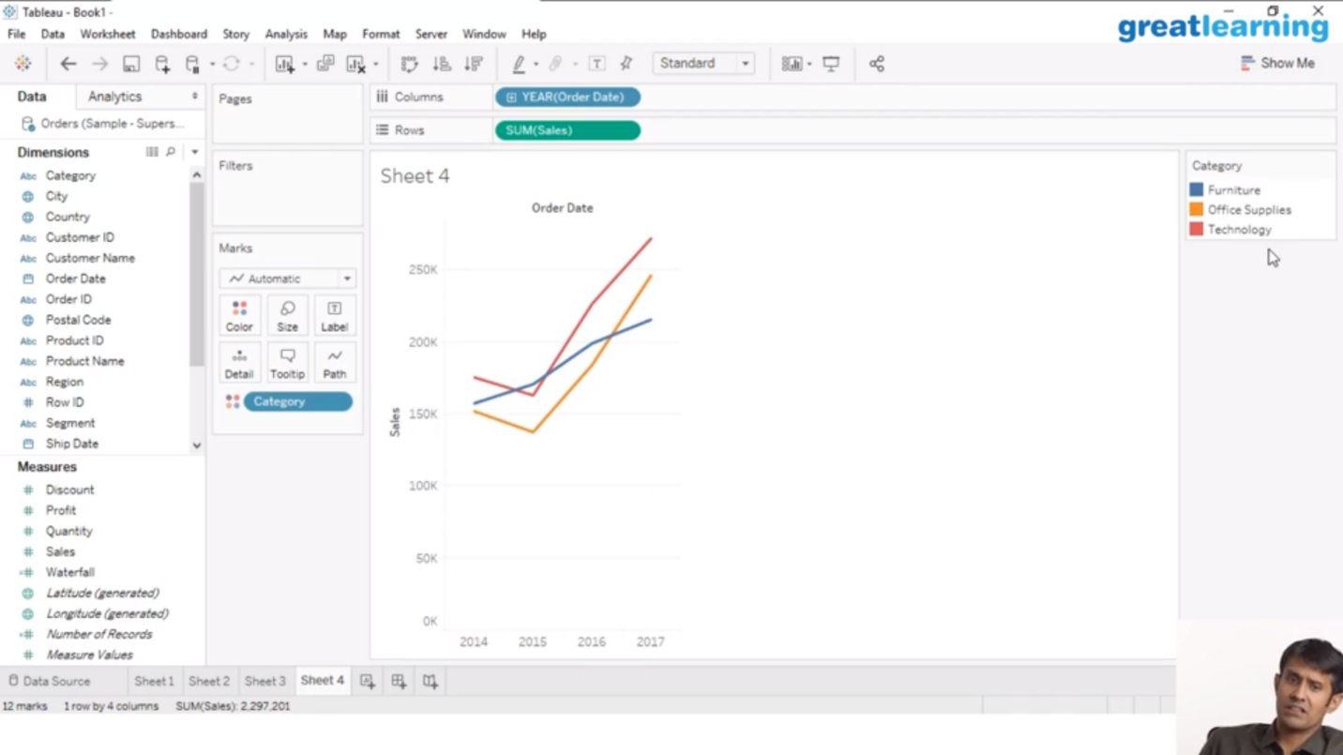

Online coding challenge

The programing statement of the day is

“Java program to find occurrence of word.”

Solution: Executed and uploaded in Github repository.

Link: <https://github.com/alvas-education-foundation/Anvitha-H-M>

